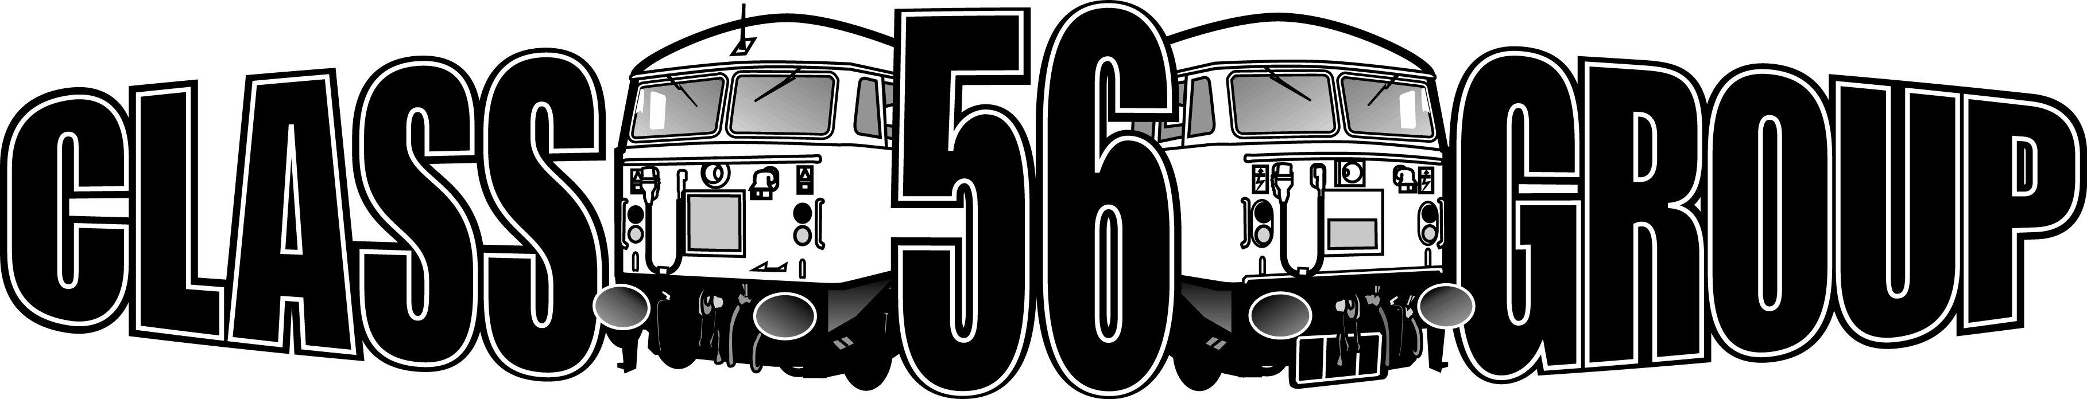

Membership Form

Name/s

Address

Postcode

Email

Mobile
YES
NO
Do you want more info on volunteering

Annual Membership Details

- Adult £15

- Concession (under 16, OAP, Disabled) £10

- Family £15 +50p per additional family member

Number of Years Subscription

Payment by Bank Transfer/Standing Order, please use your name as reference
Bank Details: The Class 56 Group Account Number 25365569 Sort Code 80-22-60

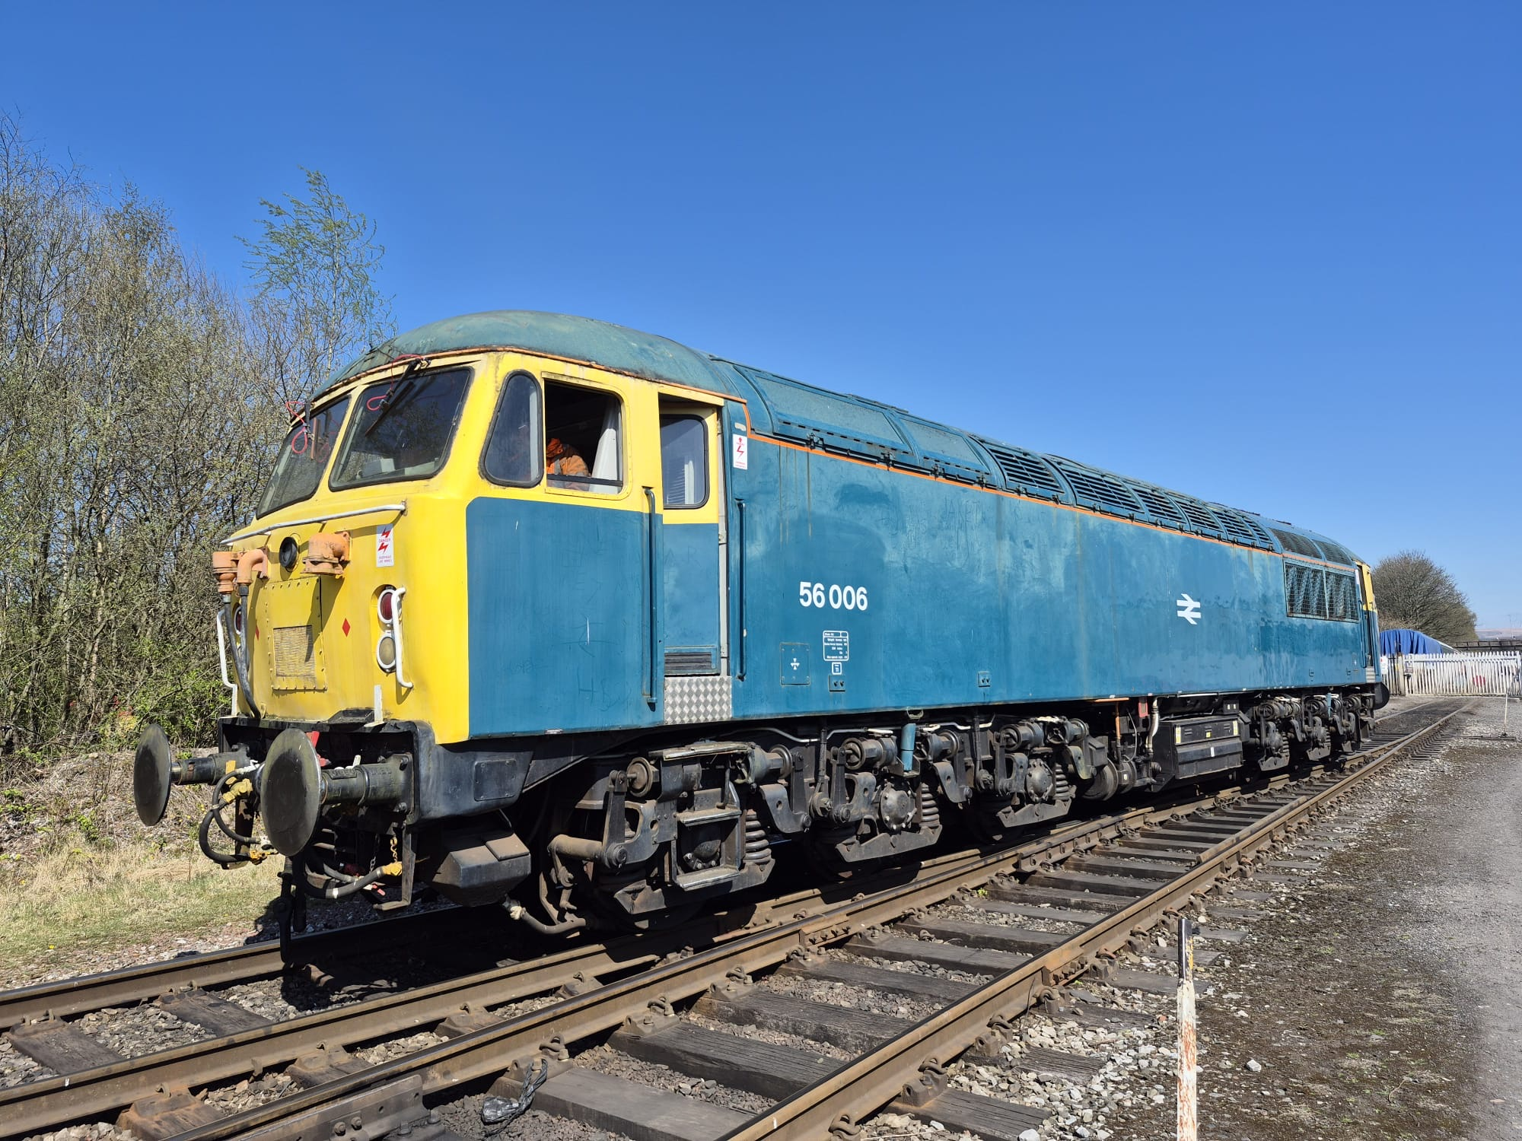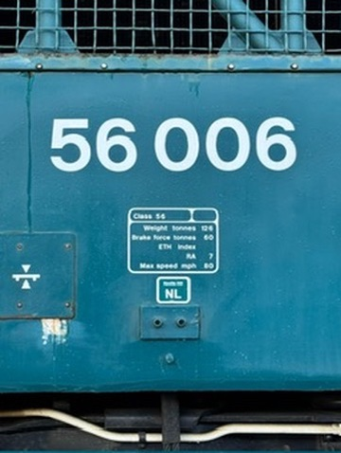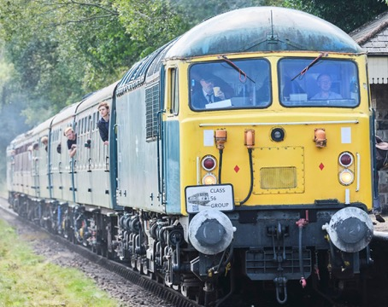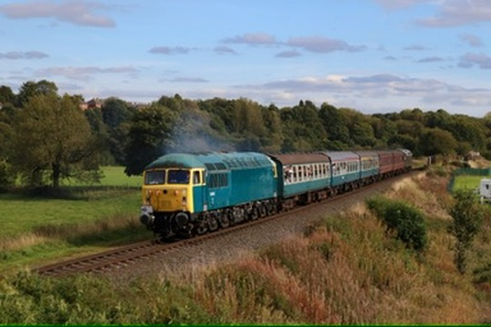

The Class 56 Group was formed in 1992 with the aim catering for people who are interested in the Class 56 locomotives and wanted to see one or more of these fine locomotives preserved for future generations to enjoy. And the Group has been able to do this so far through ownership of three Grids over the years – 56040, 56301 and 56006. Now we are down to just 56006 to which we can devote our entire energies to ensure we can highlight the place the Class 56 has in British railway history.
The Group urgently needs more funds for the continued upkeep and maintenance of 006 and by becoming a member of the Group you can support us in doing this. You could contribute further to the Group by donating or joining our share scheme, thus ensuring that the Class 56 locomotive lives on as part of British Railways history.

History of 56006

56006 has a special place in the history of the Class 56 locomotives – it was the first Grid to enter service with BR in late February 1977. When BR identified the need for a new build of locomotives for coal traffic in 1974 Brush Traction was the only bidder for the initial tender for 60 locos. The urgent need for the locos' introduction created a problem as there was no UK capability for immediate construction, so Brush outsourced the production of the first 30 locomotives to a partner they were working with in Romania, Electroputere in Craiova. The subsequent locomotives were built at BREL Doncaster (with a portion of a follow-on order built at BREL Crewe). Whilst this addressed the need to get the locos into traffic quickly, with hindsight it probably wasn't the ideal solution given the problems which quickly emerged when the first Class 56s got to the UK.
The locomotives built in Romania travelled by rail across Europe to Zeebrugge where they were loaded on to the train ferry to Harwich, before being hauled to Tinsley Depot for commissioning ahead of entry into service. The first two locomotives arrived at Zeebrugge in August 1976, with 56006 in the third batch reaching the Belgian port on 8 September. Rectification of the defects affecting the first locomotives to be delivered took six months, which meant it wasn't until 25 February 1977 than BR finally accepted 56006 into traffic. And given that the first Doncaster built example, 56031, entered traffic three months later the decision to subcontract the work abroad to help speed the introduction into service seems shortsighted.
Initially based at Tinsley – as were all the Romanian built locos – the early work for 56006 was exactly what it had been built for, merry-go-round operations taking coal from collieries to power stations. At that time there was an extensive network of mines in South Yorkshire feeding power stations such as Ferrybridge, Eggborough and Drax. And the association with that traffic was recognised in January 1995 when 56006 received the name “Ferrybridge C Power Station”
Over the course of its career 56006 has carried a number of the liveries which were applied to the Class. Starting out in BR Blue, it then appeared in original Railfreight grey livery, followed by triple grey with coal sub-sector branding, then into Loadhaul livery before returning to BR Blue livery in August 1999. The return to the original colour scheme heralded the locomotive's selection as a participant in the ‘EWS Classic Traction Event' at the East Lancashire Railway in September 1999. Following this event 56006 joined a number of other EWS locomotives in a ‘heritage pool' celebrating the history of locomotive classes which the company had inherited. In its celebrity role 56006 became an ambassador for the Class 56s in their declining years,
Following withdrawal by EWS 56006 moved to the East Lancashire Railway, where it is being cared for by a team of Class 56 Group volunteers to make sure it can continue to carry the torch as the only preserved Class 56 locomotive. As 56006's 50th anniversary approaches the Class 56 Group is confident that the locomotive will be at the forefront of generating enthusiasm for Grids for years to come – and this model plays an important role in celebrating our locomotive's past, present and future.

